Module and Position Home 1
All of our templates are packed with:
- Extensions - These are modules/plugins/component to use on this template.
- Template - This is only the template install file
- Quickstart - This is your main quickstart package, it will help you to rebuild demo.
- Documentation
If this template is not downloaded directly from amazing-templates.com. Please, go to our website and download full template pakage.
This documentation file helps you build your site manualy

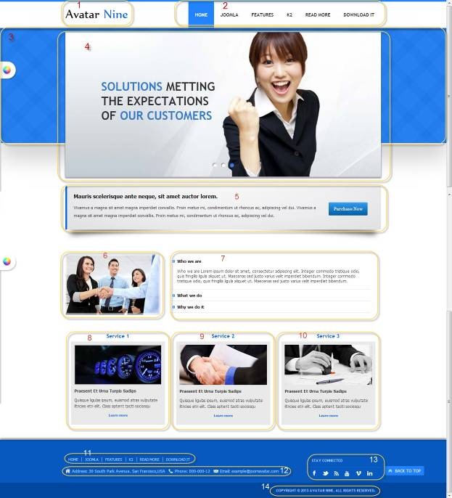

7.
Menu item type: Single Article
Article Name: WHAT DO WE SERVE ?
HTML source code:
<p>Lid est laborum dolo rumes fugats untras. Etha rums ser quidem rerum facilis dolores nemis onis fugats vitaes nemo minima rerums unsers sadips amets :</p>
<ul class="the-cross">
<li><strong><span style="line-height: 1.3em;">Lorem ipsum ex vix illud nonummy</span></strong></li>
<ul class="the-check">
<li><span style="line-height: 1.3em;">At vix scriptaset patrioque scribentur,</span></li>
<li><span style="line-height: 1.3em;">Sed et vivendo ali Lorem ipsum ex vix illud nonummy, novum tation et his. </span></li>
</ul>
<li><strong><span style="line-height: 1.3em;">Novum tation et his</span></strong></li>
<ul class="the-check">
<li><span style="line-height: 1.3em;">At vix scripta patrioque scribentur...</span></li>
<li><span style="line-height: 1.3em;">Lorem ipsum ex vix illud nonummy, novum tation et his. </span></li>
</ul>
</ul>

1.
Module Type: Custom HTML
Module Name: Logo
Module Class Suffix: no-padding-marging avatar-template-logo
Position: Top-left

HTML source code:
<p><a href="Your Link Site "><span style="color: #000;">Your</span> Site Name</a></p>

2.
Module Type: Menu
Module Name: Main Menu
Module class suffix: _menu no-padding-marging
Menu class suffix: avatar-main-menu
Alternative layout: Responsive
Position: Top-right

3.
Module Type: Custom HTML
Module Name: SOLUTIONS METTING THE EXPECTATIONS OF OUR CUSTOMERS
Module Class Suffix: avatar-separate-bg no-padding-marging
Position: content-top

HTML source code:

4.
Module Type: Avatar Articles Nivo
Module Name: Banner Tool home 1
Module Class Suffix: avatar-caption no-padding-margin-side
Module Postion: Content-top

Go to Content Manager.
Creat New Category.
Create articles in category just created.
In a newly created articles, Select intro image and written content slide.
Then go to the Banner Tool Home Manager.
Select the category for slidershow.

5.
Module Type: Custom HTML
Module Name: Slogan home 3
Module Class Suffix: no-padding-margin-side
Position: left-top

HTML source code:
<p><img src="Your Image Link" alt="" style="margin-top: 30px; display: block; margin-left: auto; margin-right: auto;" /></p>

6.
Module Type: Custom HTML
Module Name: About Us Image Home 3
Module Class Suffix: avatar-slogan no-padding-marging avatar-shadow-1
Position: content-top

HTML source code:
<p style="float: right; margin: 30px 20px;"><a class="btn" href="#" target="_blank"><span style="font-size: 13px; line-height: 24px;">Purchase Now</span></a></p>
<p><strong style="line-height: 24px; font-size: 16px; color: black;">Mauris scelerisque ante neque, sit amet auctor lorem. </strong></p>
<p><span style="line-height: 24px; font-size: 13px;">Vivamus a magna sit amet magna imperdiet convallis. Proin metus mi, condimentum ut rhoncus ac, adipiscing vel dui. </span><span style="font-size: 13px; line-height: 24px;">Vivamus a magna sit amet magna imperdiet convallis. Proin metus mi, condimentum ut rhoncus ac, adipiscing vel dui.</span><span style="font-size: 13px; line-height: 24px;"><br /></span></p>

8, 9, 10
Module Type: Custom HTML
Module Name: Service 1, Service 2, Service 3 (Show title)
Module class suffix: avatar-module-8 avatar-heading-center
Position: user-5, user-6, user-7

HTML source code:
<p style="text-align: center;"><strong><img src="Your service Image Link" alt="" /></strong></p>
<p><strong>Praesent Et Urna Turpis Sadips</strong></p>
<p>Quisque ligulas ipsum, euismod atras vulputate iltricies etri elit. Class aptent taciti sociosqu</p>
<p style="text-align: center; font-size: 10px;"><a href="Link to service article"><strong>Learn more</strong></a></p>

11.
Module Type: Menu
Module Name: Footer Menu
Module class suffix: no-padding-margin-side
Menu class suffix: avatar-footer-nav
Alternative layout: Responsive
Position: Footer-Left

12.
Module Type: Custom HTML
Module Name: Address
Module Class Suffix: avatar-module-border-top avatar-footer-address no-padding-marging
Position: Footer -left

HTML source code:
<ul style="display: table;">
<li class="avatar-address"><span style="line-height: 1.3em;">Address: Your Address</span></li>
<li class="avatar-phone"><span style="line-height: 1.3em;">Phone: Your Phone Number</span></li>
<li class="avatar-email"><span style="line-height: 1.3em;">Email: Your email</span></li>
</ul>

13.
Module Type: Custom HTML
Module Name: STAY CONNECTED
Module Class Suffix: no-padding-margin-side social-heading
Position: Footer -right
HTML source code:
<div class="avatar-footer-social avatar-module-border-top">
<a class="facebook" href="Your Facebook Link"> </a>
<a class="twitter" href="Your Twitter Link"> </a>
<a class="feed" href="Your Feed Link"> </a>
<a class="youtube" href="Your Youtube Link"> </a>
<a class="vimeo" href="Your Vimeo Link"> </a>
<a class="linkedin" href="Your Linkedin Link"> </a>
</div>

14.
Module Type: Custom HTML
Module Name: copyright
Module Class Suffix: avatar-copyright
Position: Footer

HTML source code:
<p><a href="www.joomavatar.com">Copyright © 2013 Avatar Nine. All Rights Reserved.</a></p>

